Mike Freestone
1 Starrs Close, Axbridge, Somerset, BS26 2BZ
Tel: 01934 732614
e-mail address: mikepfreestone@aol.com

Stand for your Recorders

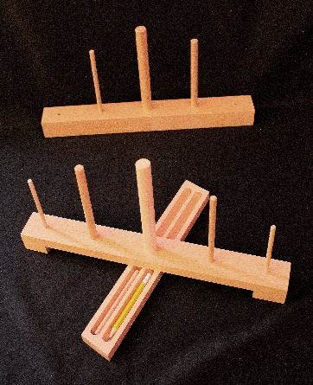
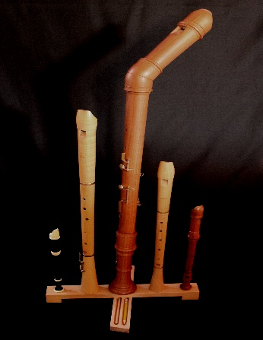

This simple but effective stand folds for easy carrying and will support Sopranino, Treble, Bass, Tenor, and Descant recorders.
The 2 smaller outer dowels can be removed and stored in the base for carrying. The stand comes with three removable dowels and a pencil, essential for recorder players.
Only £29.99 each made in solid beech
Postage costs £4.50 for UK Mainland

For orders outside mainland UK, please email for postage costs

Name: ___________________________
Address: ___________________________
___________________________
___________________________
Tel No: ___________________________

Please make cheques payable to: Mr M P Freestone
If you would like to pay by Paypal: mikepfreestone@aol.com
Bank Transfer: Name: M P Freestone
Sort Code: 40-41-22
Account No: 51017470
Mike Freestone
1 Starrs Close, Axbridge, Somerset, BS26 2BZ
Tel: 01934 732614
e-mail address: mikepfreestone@aol.com

Stand for your Recorders

This simple but effective stand folds for easy carrying and will support Sopranino, Treble, Bass, Tenor, and Descant recorders.
The 2 smaller outer dowels can be removed and stored in the base for carrying. The stand comes with three removable dowels and a pencil, essential for recorder players.
Only £29.99 each made in solid beech
Postage costs £4.50 for UK Mainland

For orders outside mainland UK, please email for postage costs

Name: ___________________________
Address: ___________________________
___________________________
___________________________
Tel No: ___________________________

Please make cheques payable to: Mr M P Freestone
If you would like to pay by Paypal: mikepfreestone@aol.com
Bank Transfer: Name: M P Freestone
Sort Code: 40-41-22
Account No: 51017470

